HD / IP Video Extender over Coax Cable

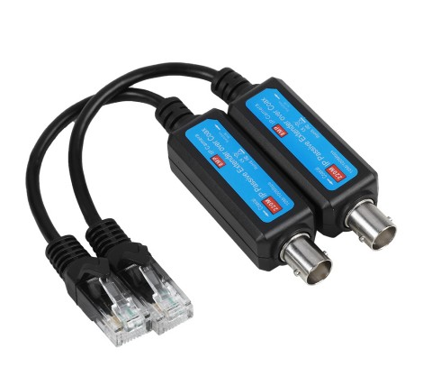
ST-IPVE8

Package:

IP EXTENDER is Designed to Extend IP Camera signal over existing coaxial cable, Transmission distance reaches max up to 220 Meters at 10Mbps Speed, IP EXTENDER is low cost and easy, simple and Speedy migration from analog to IP Camera’s using existing coax cable, Support IP Camera up to 8MP Resolution.
It widely use at Security Monitoring System, Multimedia Network Teaching System, Industrial Automation Control System, Banking, financial information display system, Hospitals, department store security, School campuses and so on....

Product Feature:
- 1 Channel Passive IP Extender over Coax
- Transmit IP Camera signal over existing coaxial Cable
- Transmission Distance max up to 220 Meters
- Passive Device, No Power Required
- Transmission Rate/Bandwidth:10/100Mbps . Half/Full Duplex Transmissions
- Built-in Surge Performance
- Fast and easy to install

Specification:
Product Name | Passive IP Extender Over Coax Transmitter / Receiver
Applied devices | CCTV Cameras, Monitors, DVR, Switchers, IP Encoders, and related CCTV equipment,
Video Format | PAL, NTSC, SECAM
Standard | IEEE802.3 10Base-T
Bandwidth | 10/100Mbps
Impedance | 5Ω to Dual 100Ω or 75Ω to Dual 100Ω or 93Ω to Dual 100Ω
Max Distance | 220M / 720Ft
Crosstalk | >30dB
Connector | Female / Male BNC, RJ45 Jack
Cable | Coax Cable (RG59)
Power | NO External Power Required
Housing | ASB Engineering Plastic
Body Color | Black
Dimension | 40X19.5X18.5 (LXW*H)
Net Weight | 40g
Operating Temperature | -20°~70℃
Relative Humidity | 0~95% (Non Condensing)
Storage Temperature | -10°~150℃

Diagram connecting:

